**Program-1**

**Write a program to find out the factorial of given number(by takimg user input).**

import java.util.Scanner;

public class Factorial {

public static void main(String[] args) {

int number;

System.out.println("Enter the number: ");

Scanner scanner = new Scanner(System.in);

number = scanner.nextInt();

scanner.close();

long fact = 1;

int i = 1;

while(i<=number)

{

fact = fact * i;

i++;

}

System.out.println("Factorial of "+number+" is: "+fact);

}

}

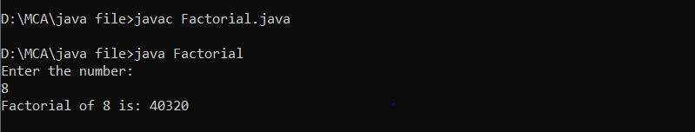

**Program-2**

**Write a program to print a following pattern(using nested loop).**

1

2 3

4 5 6

7 8 9 10

11 12 13 14 15

import java.util.Scanner;

public class pattern

{

public static void main(String[] args)

{

{

int i, j, k = 1;

for (i = 1; i <= 5; i++)

{

for (j = 1; j< i + 1; j++)

{

System.out.print(k++ + " ");

}

System.out.println();

}

}

}

}

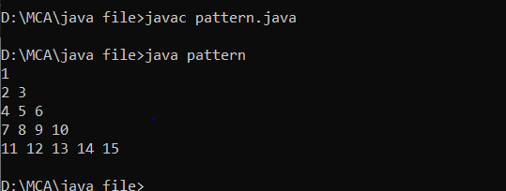

**Program-3**

**Write a program to find out that given number is palindrome or not.**

public class Palindrome {

public static void main(String[] args) {

int rem, rev= 0, temp;

int n=121; // user defined number to be checked for palindrome

temp = n;

// reversed integer is stored in variable

while( n != 0 )

{

rem= n % 10;

rev= rev * 10 + rem;

n=n/10;

}

// palindrome if orignalInteger(temp) and reversedInteger(rev) are equal

if (temp == rev)

System.out.println(temp + " is a palindrome.");

else

System.out.println(temp + " is not a palindrome.");

}

}

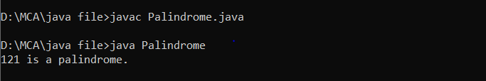

**Program-4**

**Write a program to find out the Multiplication of two number given by user.**

import java.util.Scanner;

public class Multiplication {

public static void main(String args[]){

Scanner sc = new Scanner(System.in);

System.out.println("Enter the value of the first number ::");

int a = sc.nextInt();

System.out.println("Enter the value of the second number ::");

int b = sc.nextInt();

int result = a*b;

System.out.println("Product of the given two numbers is ::"+result);

}

}

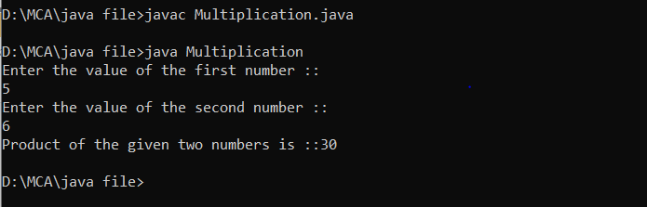

**Program-5**

**Write a program to Addition of two matrices**

class ArrAddMatrics{

public static void main(String args[]){

int m1[][]={{2,4,6},{3,5,7},{4,8,12}};

int m2[][]={{2,4,6},{3,5,7},{4,8,12}};

int add[][]=new int[3][3];

System.out.println("Addition of matrix");

for(int i=0;i<3;i++)

{

for(int j=0;j<3;j++)

{

add[i][j]=0;

for(int k=0;k<3;k++)

{

add[i][j]=add[i][j]+m1[i][k]+m2[k][j];

System.out.print(add[i][j]+" ");

}

System.out.println();

}

}

}

}

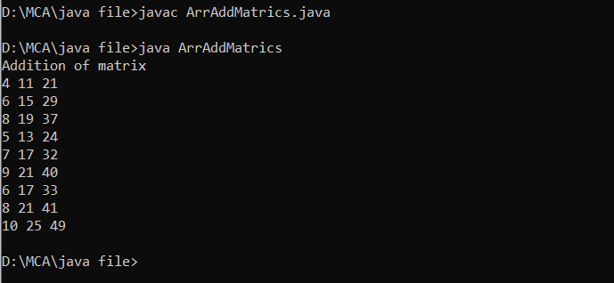

**Program-6**

**Write a program to Multiplication of two matrices**

class ArrMulMatrics{

public static void main(String args[]){

int m1[][]={{2,4,6},{3,5,7},{4,8,12}};

int m2[][]={{2,4,6},{3,5,7},{4,8,12}};

int mul[][]=new int[3][3];

System.out.println("Multiplication of matrix");

for(int i=0;i<3;i++)

{

for(int j=0;j<3;j++)

{

mul[i][j]=0;

for(int k=0;k<3;k++)

{

mul[i][j]=mul[i][j]+m1[i][k]+m2[k][j];

}

System.out.print(mul[i][j]+" ");

}

System.out.println();

}

}

}

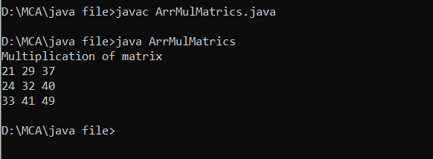

**Program-7**

**Write a program that will display the sum of 1+1/2+1/3....+1/n.**

import java.util.Scanner;

class Program1

{

public static void main(String[] args)

{

Scanner sc=new Scanner(System.in);

double sum=0,n,i;

System.out.println("Please Enter the value of N:=");

n=sc.nextDouble();

for(i=1;i<=n;i++)

{

sum=sum+(1/i);

if(i==1)

System.out.print("1 + ");

else if(i==n)

System.out.print("1/"+i);

else

System.out.print("1/"+i+" + ");

}

System.out.println();

System.out.println("THE SUM OF THIS SERIES IS:="+sum);

}

}

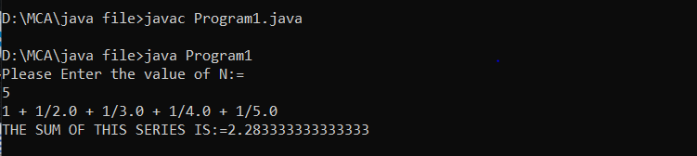

**Program-8**

**(i)Write a program that will display 25 prime numbers.**

class PrimeNumbers

{

public static void main (String[] args)

{

int i =0;

int num =0;

//Empty String

String primeNumbers = "";

for (i = 1; i <= 100; i++)

{

int counter=0;

for(num =i; num>=1; num--)

{

if(i%num==0)

{

counter = counter + 1;

}

}

if (counter ==2)

{

//Appended the Prime number to the String

primeNumbers = primeNumbers + i + " ";

}

}

System.out.println("Prime numbers from 1 to 100 are :");

System.out.println(primeNumbers);

}

}

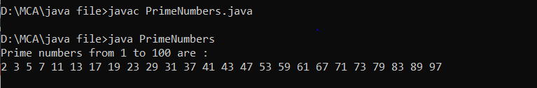

**(ii)Write a program to show the PUSH and POP operation on stack by using the Constructor.**

import java.util.Stack;

public class StackEmptyMethod

{

public static void main(String[] args)

{

//creating an instance of Stack class

Stack<Integer> stk= new Stack<>();

// checking stack is empty or not

boolean result = stk.empty();

System.out.println("Is the stack empty? " + result);

// pushing elements into stack

stk.push(78);

stk.push(113);

stk.push(90);

stk.push(120);

//prints elements of the stack

System.out.println("Elements in Stack: " + stk);

result = stk.empty();

System.out.println("Is the stack empty? " + result);

}

}

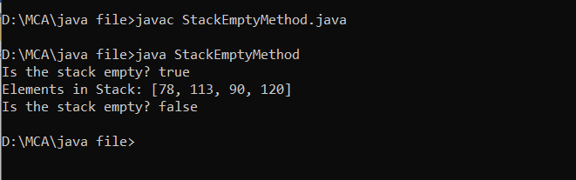

**Program-9**

**Write a program that uses the use of inheritance.**

class First

{ int i=10;

void inherit()

{

System.out.println("Hello");

}

}

class Second extends First

{

void inherit()

{

System.out.println("World");

}

public static void main(String args[])

{

Second s=new Second();

s.inherit();

System.out.println(s.i);

}

}

**Output** - Hello World

**Program-10**

**Write a program to implement Multiple Interfaces.**

interface A

{

void show();

}

interface B

{

void disp();

}

class INNER implements A,B

{

public void show()

{

System.out.println("This Is Interface A");

}

public void disp()

{

System.out.println("This Is Interface B");

}

public static void main(String arg[])

{

INNER obj= new INNER();

obj.show();

obj.disp();

}

}

**Output** - This is Interface A

This is Interface B

**Program-11**

**Write a program to method overloading.**

class overloading

{

void add(int a, int b)

{

int c=a+b;

System.out.println("The sum of two number:"+c);

}

void add (int a, int b, int c)

{

int d=a+b+c;

System.out.println("The sum of three number:"+d);

}

public static void main(String args[])

{

overloading ob=new overloading();

ob.add(10,20);

ob.add(10,20,40);

}

}

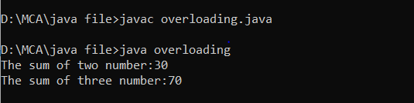

**Program-12**

**Write a program to method overriding.**

class Employee

{

void getsalary()

{

System.out.println("We can't tell employee salary");

}

}

class developer extends Employee

{

int salary=70000;

void getsalary()

{

System.out.println("Developer salary is:"+salary);

}

}

class tester extends Employee

{

int salary=50000;

void getsalary()

{

System.out.println("tester salary is:"+salary);

}

}

class designer extends Employee

{

int salary=60000;

void getsalary()

{

System.out.println("designer salary is:"+salary);

}

}

class overridding

{

public static void main (String args[])

{

Employee e;

developer d=new developer();

e=d;

e.getsalary();

tester t=new tester();

e=t;

e.getsalary();

designer de=new designer();

e=de;

e.getsalary();

}

}

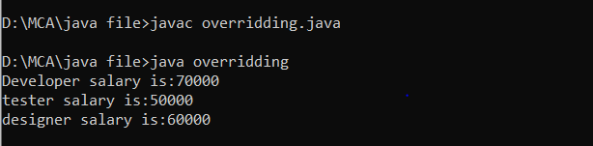

**Program-13**

**Write a program to show the use of abstract class.**

abstract class Sum

{

public abstract int sumOfTwo(int n1, int n2);

public abstract int sumOfThree(int n1, int n2, int n3);

public void display()

{

System.out.println("Method of class Sum :");

}

}

class Demo extends Sum

{

public int sumOfTwo(int num1, int num2)

{

return num1+num2;

}

public int sumOfThree(int num1, int num2, int num3)

{

return num1+num2+num3;

}

public static void main(String args[])

{

Sum obj = new Demo();

obj.display();

System.out.println(obj.sumOfTwo(3, 7));

System.out.println(obj.sumOfThree(4, 3, 19));

}

}

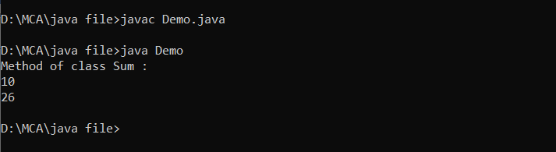

**Program-14**

**Write a program which shows creation of package and importing of a classes from other packages .**

package pack1;

import pack2.Student

public class Example

{

public static void main(String []args)

{

Student s1=new Student();

s1.setRollno(22);

s1.setName("Richa !");

}

System.out.println("Student Roll Number = "+getRollno());

System.out.println("Student Full Name = "+getName());

}

**Output** – Student Roll Number = 22

Student Full Name = Richa!

**Program-15**

**Write a java program which use try and catch ,finally for exception handling.**

public class TryCatchExample{

public static void main(String[] args) {

try

{

int data=50/0; //may throw exception

}

//handling the exception

catch(ArithmeticException e)

{

System.out.println(e);

}

System.out.println("rest of the code");

}

}

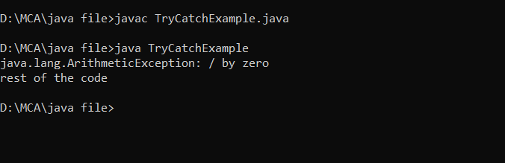

**Program-16**

**Write a java program which use throw keyword**.

class ThrowEx

{

static void validate(int age)

{

if (age<18)

{

throw new ArithmeticException("You are not eligible for voting");

}

else

{

System.out.println("You are eligible for voting");

}

}

public static void main(String args[])

{

ThrowEx.validate(17);

}

}

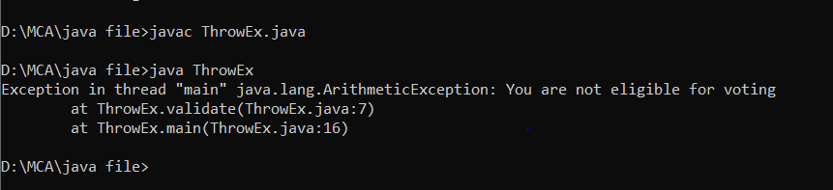

**Program-17**

**Write a java program which use throws keyword.**

import java.io.IOException;

class throws1{

void m()throws IOException{

throw new IOException("device error");//checked exception

}

void n()throws IOException{

m();

}

void p(){

try{

n();

}catch(Exception e){System.out.println("exception handled");}

}

public static void main(String args[]){

throws1 obj=new throws1();

obj.p();

System.out.println("normal flow...");

}

}

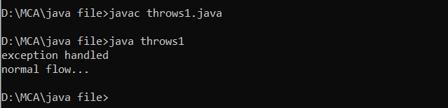

**Program-18**

**Write a java program which use Custom Exception keyword.**

class InvalidAgeException extends Exception{

InvalidAgeException(String s){

super(s);

}

}

class CustomException1{

static void validate(int age)throws InvalidAgeException{

if(age<18)

throw new InvalidAgeException("not valid");

else

System.out.println("welcome to vote");

}

public static void main(String args[]){

try{

validate(13);

}catch(Exception m){System.out.println("Exception occured: "+m);}

System.out.println("rest of the code...");

}

}

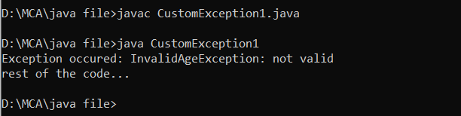

**Program-19**

**Write a program to show sleep concept in java.**

class sleep

{

public static void main(String args[])

{

try{

Thread.sleep(5000);

}

catch(InterruptedException e)

{

System.out.println(e);

}

System.out.println("Hello main thread");

}

}

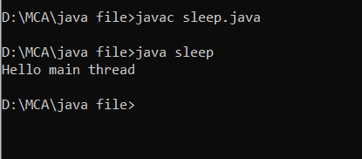

**Program-20**

**Write a program to concept of default constructor in java.**

class DefaultConstructor{

int rollno;

String name;

void display(int r,String n){

rollno=r;

name=n;

System.out.println("Student Roll number : "+rollno+" Student Name : "+name);

}

public static void main(String args[]){

DefaultConstructor st=new DefaultConstructor();

st.display(15,"RICHA KUMARI");

}

}

